Project for Database Design

Phase III. Implementation

# 0. Pre-Illumination

To clearly describe the implementation of our database, I separate this report into four sections. Section 1 is the project description and Section 2 is the updated relational schema that meets the third normal form to avoid anomaly in data update, insertion & deletion. Section 3 includes the dependency diagrams that I draw for each relation table. Then in Section 4, I used SQL statements to build the relational database in Oracle, created views and queries to answer business questions. Finally, a short summary is given at the end of this report.

# 1. Project Description

Dallas Care is a hospital and medical care center. Dallas Care would like one relational database to be able to smoothly carry out their work in an organized way. The hospital has following modules: Person, Employee, Patient, Visitors, Pharmacy, Treatment, Rooms, Records and Medical Bill Payment.

A Person can be an Employee or a Class 1 Patient. Details of a person such as Person ID, Name (First, Middle, Last), Address, Gender, Date of Birth, and Phone number (one person can have more than one phone number) are recorded. A person ID should be in the format, ‘PXXX’, where XXX can be a value between 100 and 999. A Class 1 patient is a person who visits the hospital just for a doctor consultation. A person can be both an employee and a Class 1 patient.

Employee is further classified as Doctors, Nurses or Receptionists. The start date of the employee is recorded. The specialization of the doctor is stored and doctors are further classified into Trainee, Permanent or Visiting. Every Class 1 patient consults a doctor. A Class 1 patient can consult at most one doctor but one doctor can be consulted by more than one Class 1 patient.

A Class 2 patient is a someone who is admitted into the hospital. A Class 2 patient can be an Employee or a Class 1 Patient or both. A doctor attends Class 2 patients. One doctor can attend many Class 2 patients but a Class 2 patient can be attended to by at most 2 doctors. The date of patient being admitted into the hospital is recorded.

A Visitor log is maintained for the Class2 Patients, which stores information such as patient ID, visitor ID, visitor name, visitor’s address, and visitor’s contact information.

Pharmacy details such as Medicine code, Name, Price, Quantity and Date of expiration is recorded. The database also stores the information of the various kinds of treatments that are offered in the hospital. The treatment details such as ID, name, duration and associated medicines are recorded. When a treatment is assigned to a Class 2 patient, the treatment details, medicine details and patient details are recorded so that the doctor can easily access this information.

Nurses governs rooms. Each nurse can govern more than one room, but each room has only one nurse assigned to it. The room details such as room ID, room type and duration is recorded. Each Class 2 patient is assigned a room on being admitted to the hospital.

A records database is maintained by the receptionist who keeps record of information such as record ID, patient ID, date of visit, appointment and description. The receptionist also records the payment information with the patient’s ID, date of payment and the total amount due. Payment is further classified into Cash or Insurance. A person can pay by cash, or by insurance or pay via a combination of both. The cash amount is recorded if a person pays by cash. For Insurance, the insurance details such as Insurance ID, Insurance Provider, Insurance coverage and the amount is recorded.

# 2. Relational Schema

The updated relational schema is shown in the following figure:

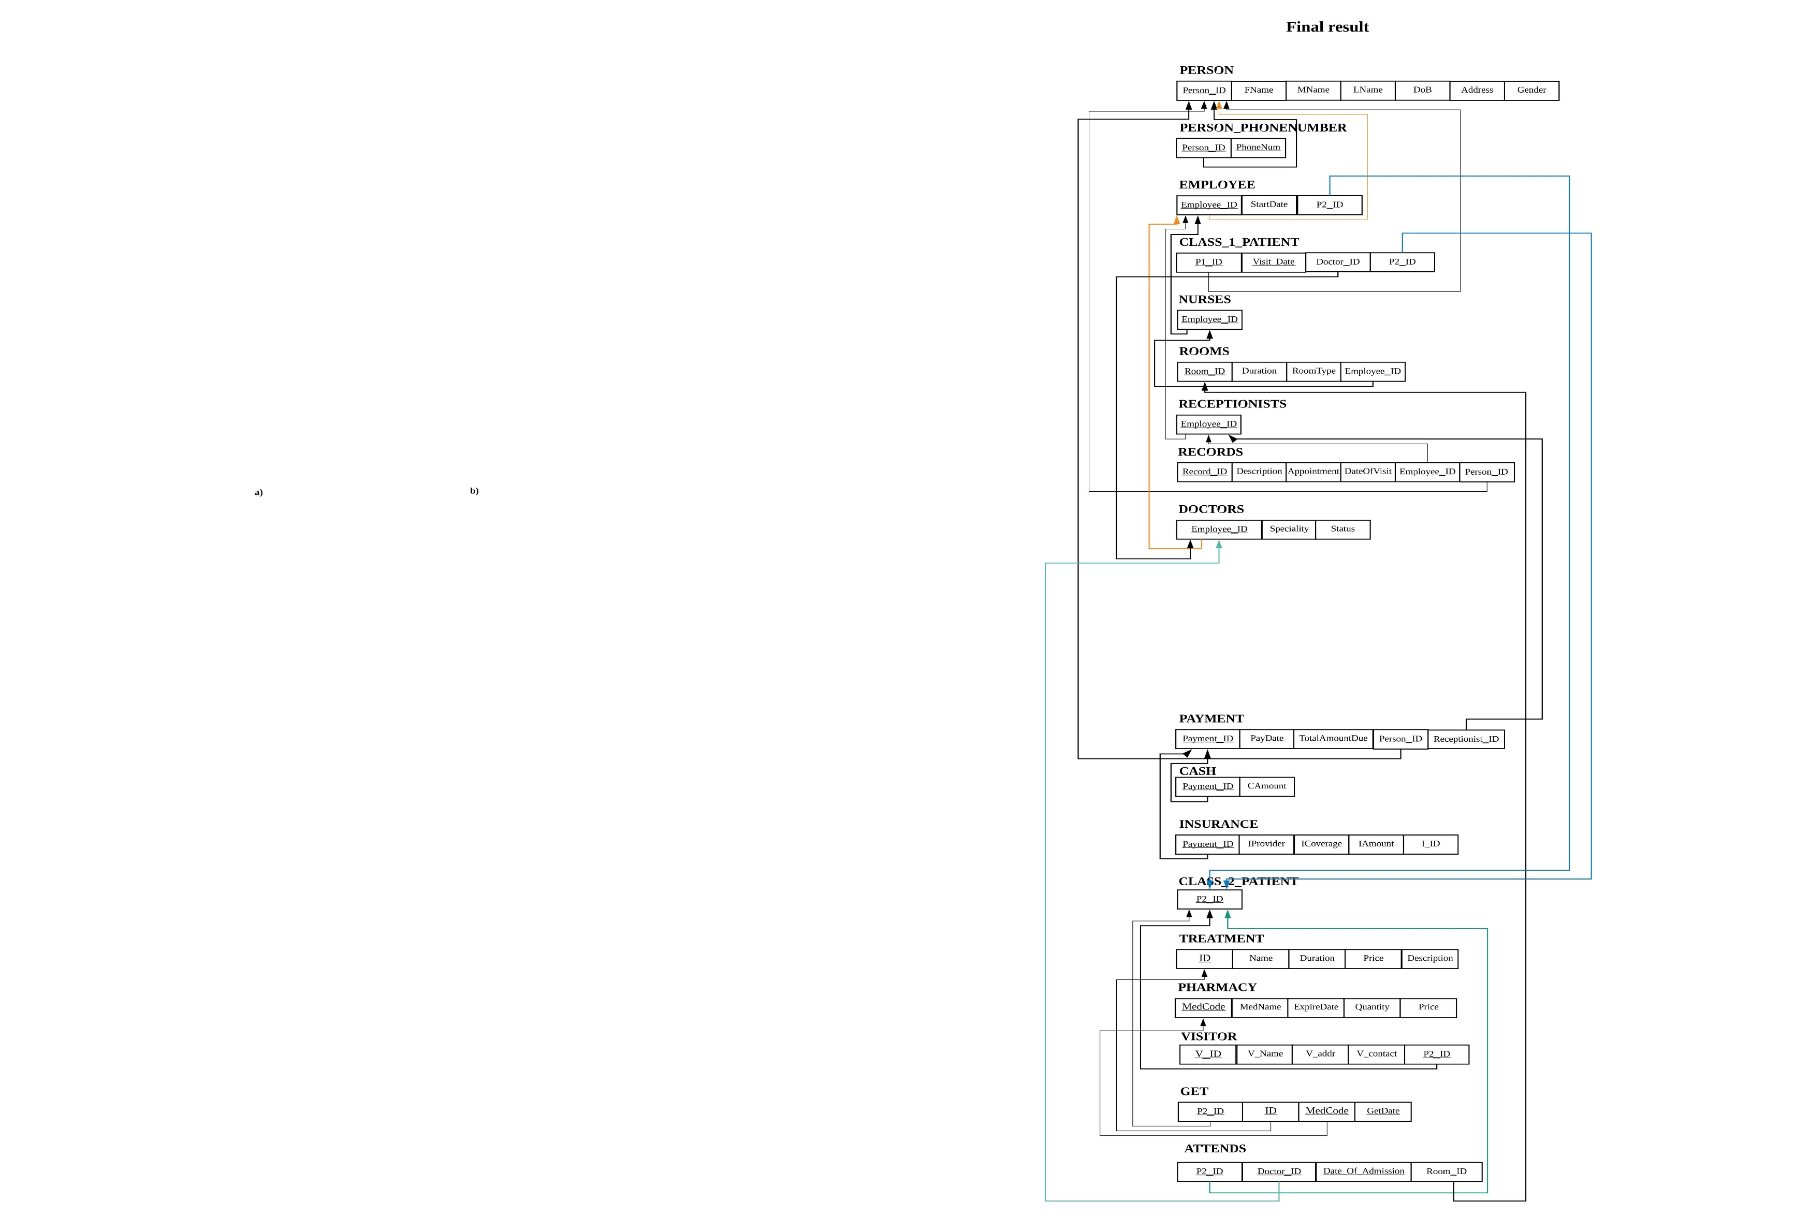

# 3. Dependency Diagram

We now draw a dependency diagram for each table from Figure 1 as follows:

## 3.1 PERSON

There is only one attribute in the left-hand side of the functional dependencies, which is the key of relational schema PERSON, Person_ID. Therefore, every other attribute of this relational schema is functionally dependent on Person_ID. The dependency diagram is shown as Figure 3.1.

PERSON

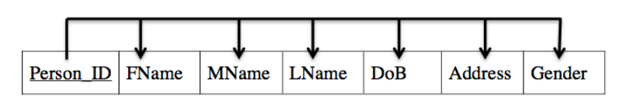

Figure 3.1. Dependency Diagram of PERSON

## 3.2 EMPLOYEE

There is only one attribute in the left-hand side of the functional dependencies, which is the key of relational schema EMPLOYEE, EMPLOYEE_ID. Therefore, every other attribute of this relational schema is functionally dependent on EMPLOYEE_ID. The dependency diagram is shown as Figure 3.2.

EMPLOYEE

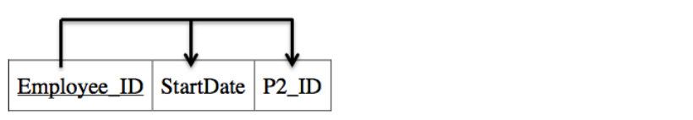

Figure 3.2 Dependency Diagram of EMPLOYEE.

## 3.3 CLASS_1_PATIENT

The attributes P1_ID and Visit_Date are part of the primary key. Every other attribute of this relational schema is functionally dependent on primary key. The dependency diagram is shown as Figure 3.3.

CLASS_1_PATIENT

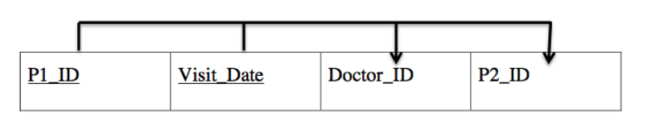

Figure 3.3 Dependency Diagram of CLASS_1_PATIENT.

## 3.4 ROOMS

There is only one attribute in the left-hand side of the functional dependencies, which is the key of relational schema ROOMS, Room _ID. Therefore, every other attribute of this relational schema is functionally dependent on Room _ID. The dependency diagram is shown as Figure 3.4.

ROOMS

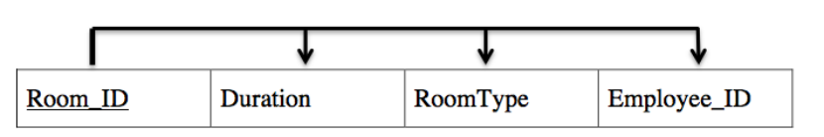Figure 3.4 Dependency Diagram of ROOMS.

## 3.5 RECORDS

There is only one attribute in the left-hand side of the functional dependencies, which is the key of relational schema RECORDS, Record _ID. Therefore, every other attribute of this relational schema is functionally dependent on Record _ID. The dependency diagram is shown as Figure 3.5.

RECORDS

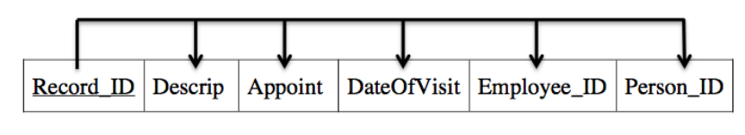

Figure 3.5 Dependency Diagram of RECORDS.

## 3.6 DOCTORS

There is only one attribute in the left-hand side of the functional dependencies, which is the key of relational schema DOCTORS, Employee _ID. Therefore, every other attribute of this relational schema is functionally dependent on Employee _ID. The dependency diagram is shown as Figure 3.6.

DOCTORS

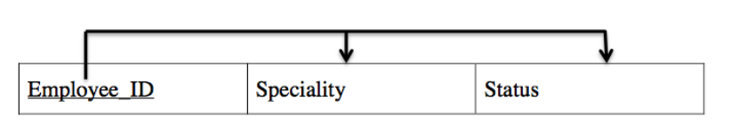

Figure 3.6 Dependency Diagram of DOCTORS.

## 3.7 PAYMENT

There is only one attribute in the left-hand side of the functional dependencies, which is the key of relational schema PAYMENT, Payment_ID. Therefore, every other attribute of this relational schema is functionally dependent on Payment_ID. The dependency diagram is shown as Figure 3.7.

PAYMENT

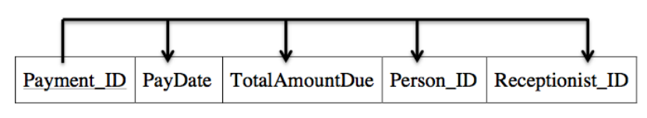

Figure 3.7 Dependency Diagram of PAYMENT.

## 3.8 CASH

There is only one attribute in the left-hand side of the functional dependencies, which is the key of relational schema CASH, Payment_ID. Therefore, every other attribute of this relational schema is functionally dependent on Payment_ID. The dependency diagram is shown as Figure 3.8.

CASH

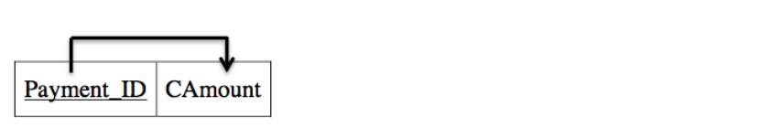

Figure 3.8 Dependency Diagram of CASH.

## 3.9 INSURANCE

There is only one attribute in the left-hand side of the functional dependencies, which is the key of relational schema INSURANCE, Payment_ID. Therefore, every other attribute of this relational schema is functionally dependent on Payment_ID. The dependency diagram is shown as Figure 3.9.

INSURANCE

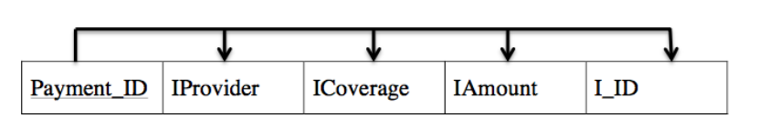

Figure 3.9 Dependency Diagram of INSURANCE.

## 3.10 TREATMENT

There is only one attribute in the left-hand side of the functional dependencies, which is the key of relational schema TREATMENT, ID. Therefore, every other attribute of this relational schema is functionally dependent on ID. The dependency diagram is shown as Figure 3.10.

TREATMENT

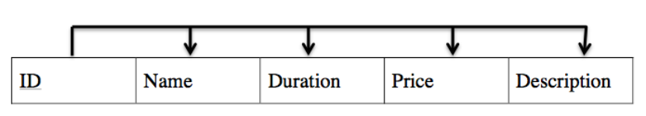

Figure 3.10 Dependency Diagram of TREATMENT.

## 3.11 PHARMACY

There is only one attribute in the left-hand side of the functional dependencies, which is the key of relational schema PHARMACY, MedCode. Therefore, every other attribute of this relational schema is functionally dependent on MedCode. The dependency diagram is shown as Figure 3.11.

PHARMACY

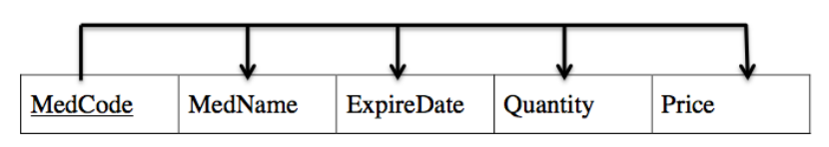

Figure 3.11 Dependency Diagram of PHARMACY.

## 3.12 VISITOR

There is only one attribute in the left-hand side of the functional dependencies, which is the key of relational schema VISITOR, V_ID. Therefore, every other attribute of this relational schema is functionally dependent on V_ID. The dependency diagram is shown as Figure 3.12.

VISITOR

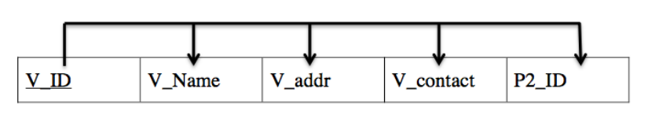

Figure 3.12 Dependency Diagram of VISITOR.

## 3.13 ATTENDS

The attributes P2_ID, Doctor_ID and Date_Of_Admission are part of the key. The only nonkey attribute Room_ID is functionally dependent on key. The dependency diagram is shown as Figure 3.13.

ATTENDS

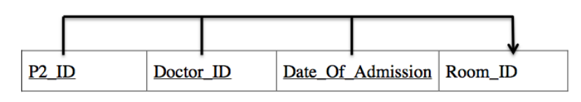

Figure 3.13 Dependency Diagram of ATTENDS.

## 3.14 Final Results

After drawing the dependency diagrams one after another, Figure 3.14 shows the final results for the whole database including the ones who do not have any functional dependencies.

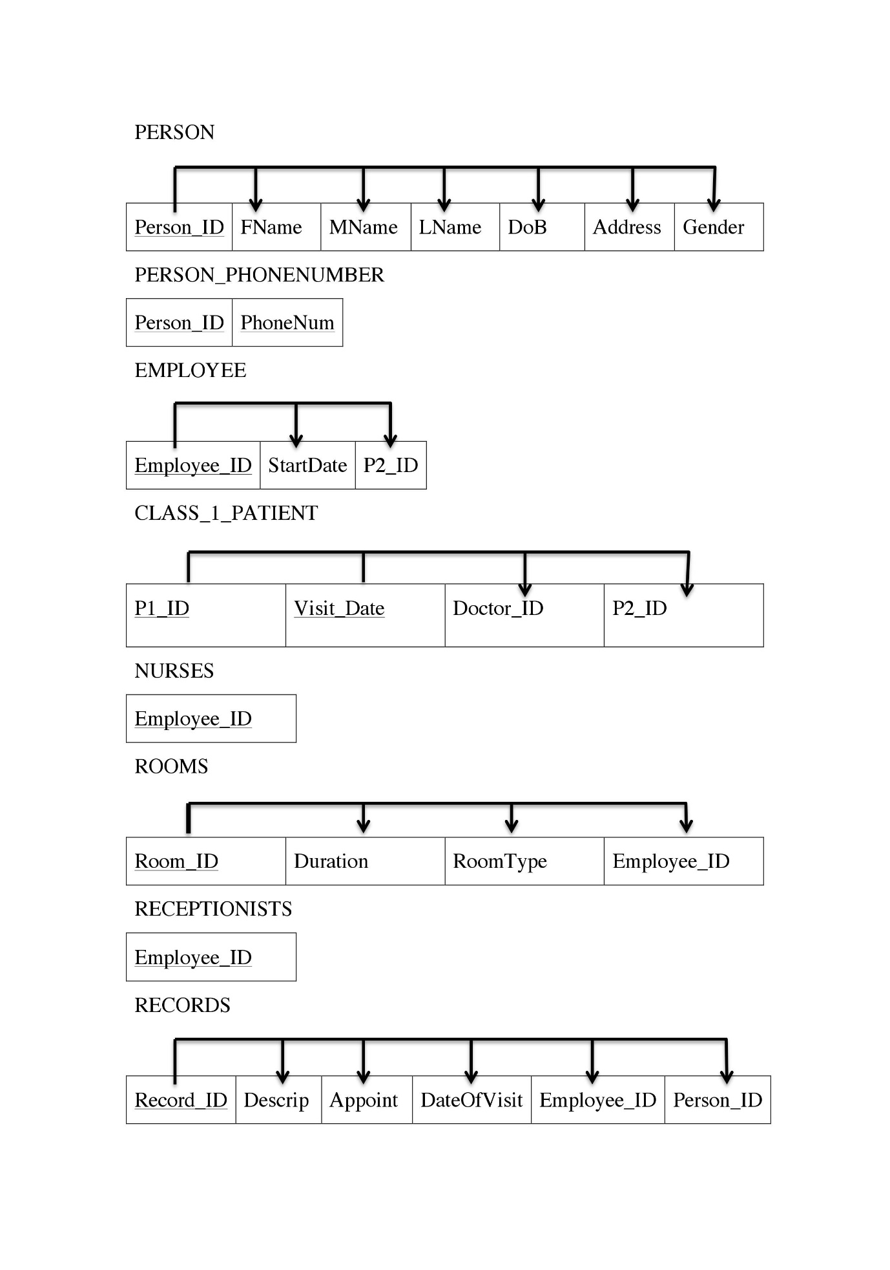

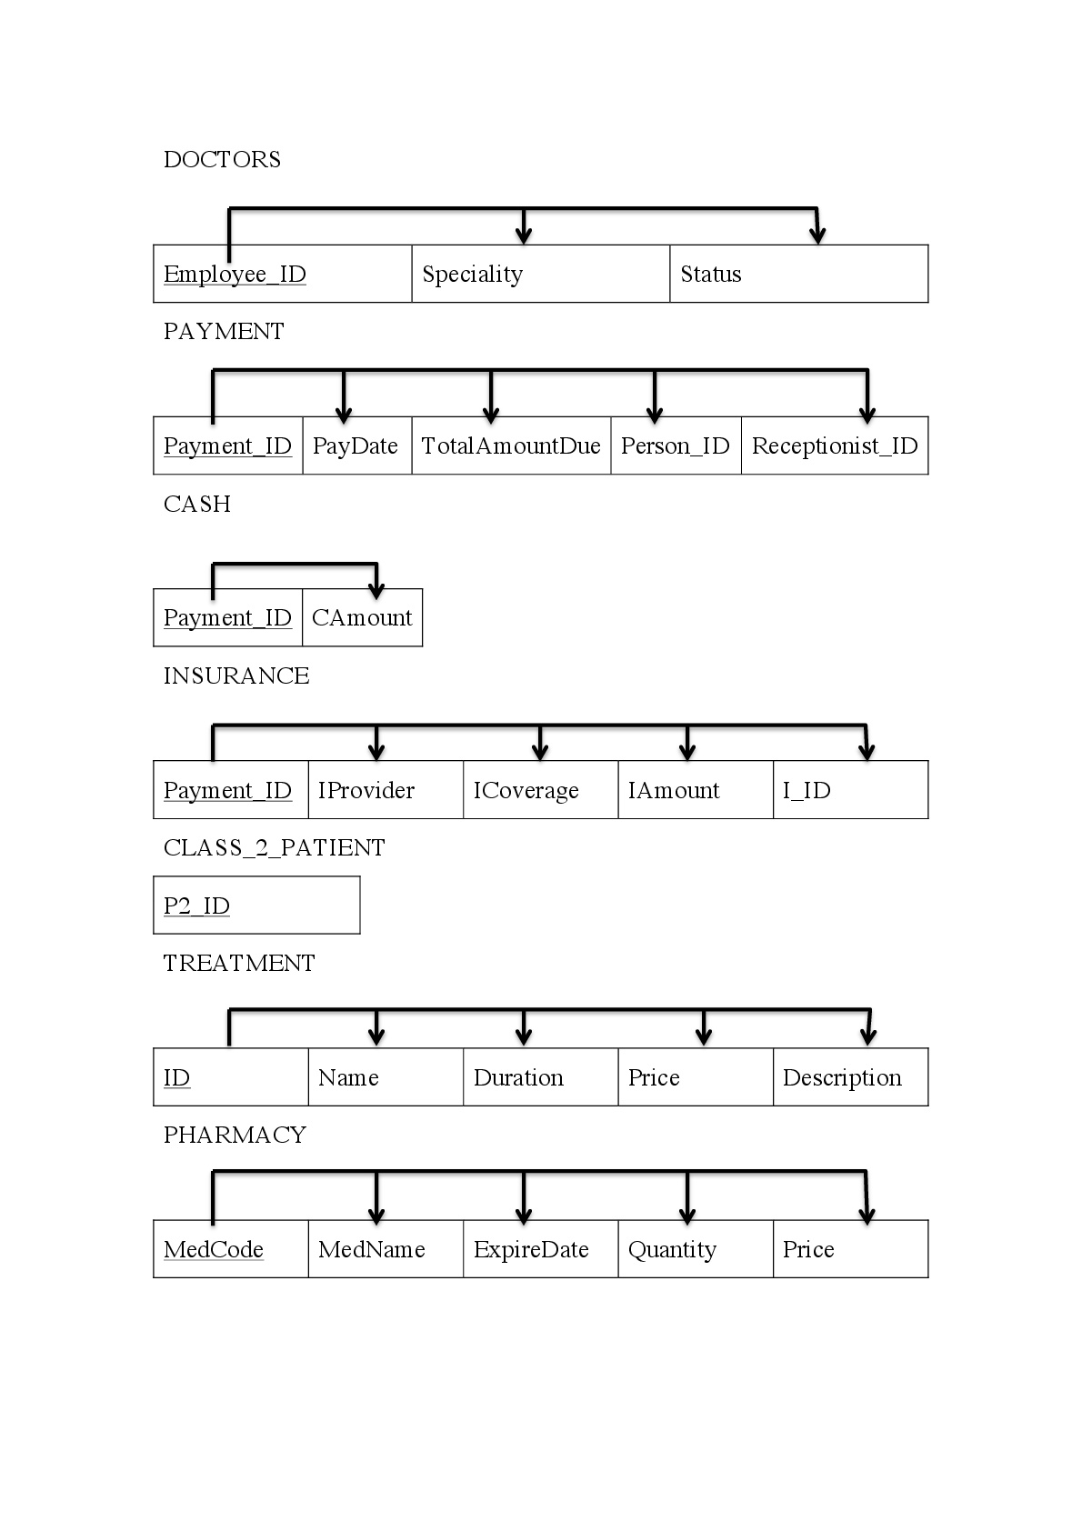

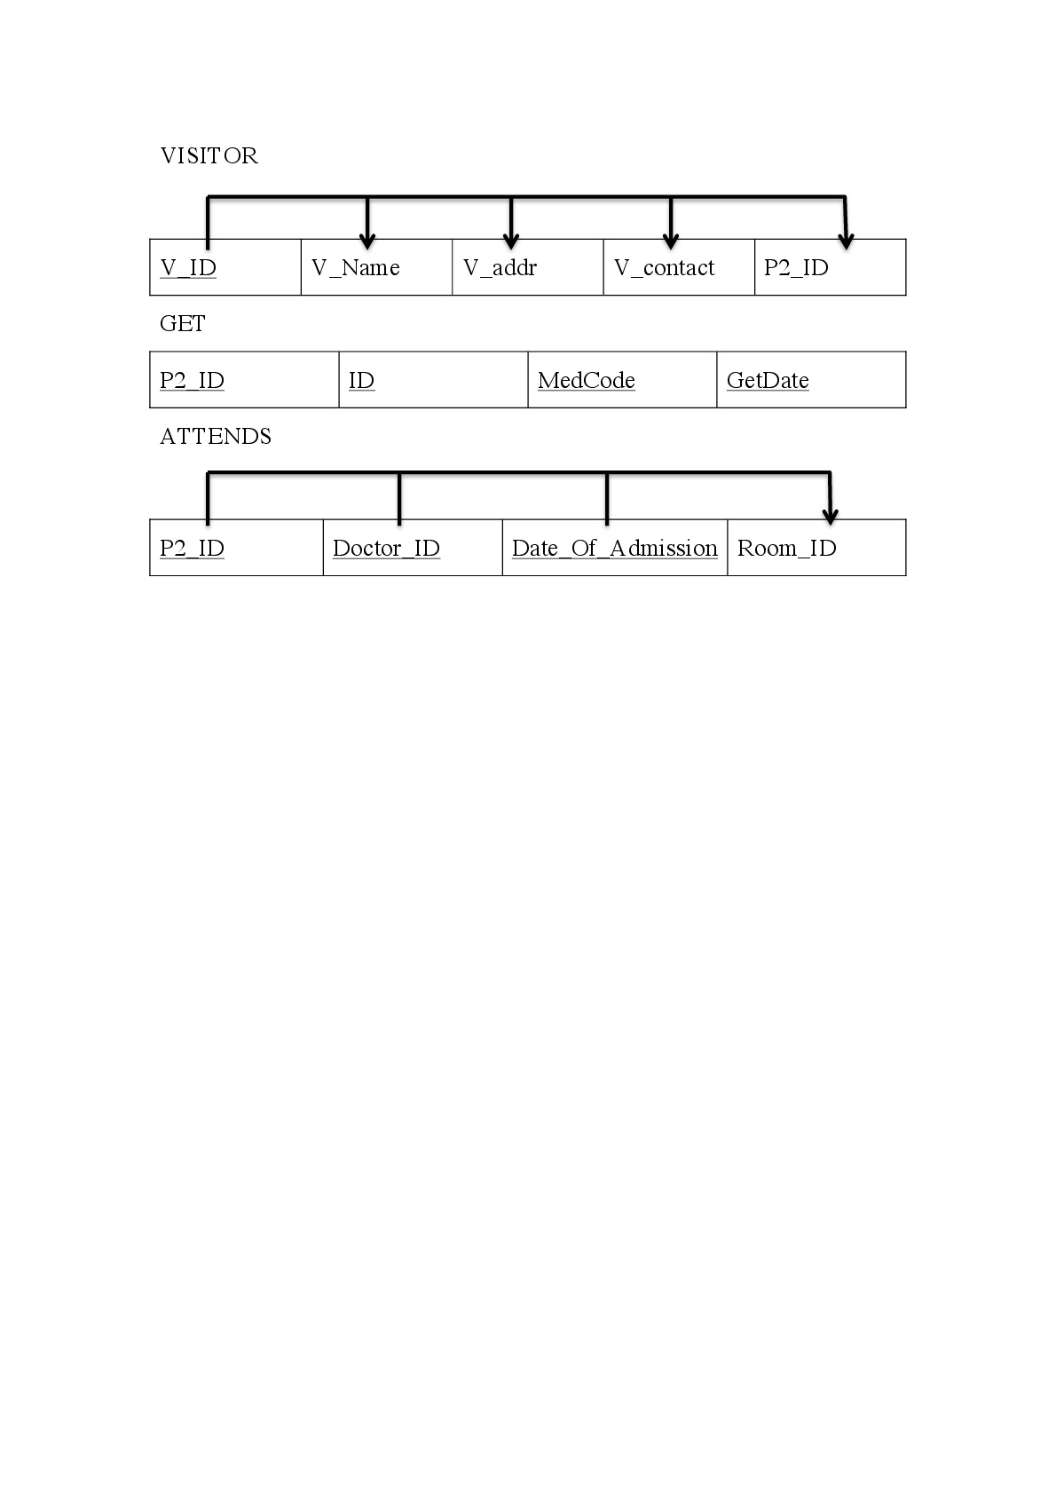

Figure 3.14 Dependency Diagram of all tables.

# 4. Implementation of Database

## 4.1 Creation of Database with SQL Statements

After normalizing every relational schema into third normal form and modifying some details, it is the time to implement our database using SQL languages into Oracle.

### 4.1.1 Table Creation

Using SQL statement, we created all 18 tables as follows:

PERSON:

CREATE TABLE PERSON (

PERSON_ID CHAR(4), CHECK ( PERSON_ID like 'P%' ),

FNAME CHAR(30) NOT NULL,

MNAME CHAR(30),

LNAME CHAR(30) NOT NULL,

DOB DATE NOT NULL,

ADDRESS CHAR(200) NOT NULL,

GENDER CHAR(1) NOT NULL,

PRIMARY KEY (PERSON_ID)

);

CLASS_2_PATIENT:

CREATE TABLE CLASS_2_PATIENT(

P2_ID CHAR(4),

PRIMARY KEY(P2_ID)

);

EMPLOYEE:

CREATE TABLE EMPLOYEE(

EMPLOYEE_ID CHAR(4),

STARTDATE DATE NOT NULL,

P2_ID CHAR(4),

PRIMARY KEY(EMPLOYEE_ID),

FOREIGN KEY(EMPLOYEE_ID) REFERENCES PERSON(PERSON_ID),

FOREIGN KEY(P2_ID) REFERENCES CLASS_2_PATIENT(P2_ID)

);

DOCTORS:

CREATE TABLE DOCTORS(

EMPLOYEE_ID CHAR(4),

SPECIALITY CHAR(30) NOT NULL,

STATUS CHAR(1) NOT NULL, CHECK( STATUS IN ('T','V','P') ),

PRIMARY KEY ( EMPLOYEE_ID ),

FOREIGN KEY ( EMPLOYEE_ID ) REFERENCES EMPLOYEE ( EMPLOYEE_ID )

);

NURSES:

CREATE TABLE NURSES (

EMPLOYEE_ID CHAR(4),

PRIMARY KEY (EMPLOYEE_ID),

FOREIGN KEY (EMPLOYEE_ID) REFERENCES EMPLOYEE ( EMPLOYEE_ID )

);

ROOMS:

CREATE TABLE ROOMS(

ROOM_ID INTEGER,

Duration INTEGER,

ROOMTYPE CHAR(1) NOT NULL,

EMPLOYEE_ID CHAR(4),

PRIMARY KEY(ROOM_ID),

FOREIGN KEY(EMPLOYEE_ID) REFERENCES NURSES(EMPLOYEE_ID)

);

RECEPTIONISTS:

CREATE TABLE RECEPTIONISTS(

EMPLOYEE_ID CHAR(4),

PRIMARY KEY(EMPLOYEE_ID),

FOREIGN KEY(EMPLOYEE_ID) REFERENCES EMPLOYEE(EMPLOYEE_ID)

);

PAYMENT:

CREATE TABLE PAYMENT(

PAYMENT_ID INTEGER,

PAY_DATE DATE,

TOTAL_AMOUNT_DUE NUMBER(12,2) NOT NULL,

PERSON_ID CHAR(4) NOT NULL,

RECEPTIONIST_ID CHAR(4) NOT NULL,

PRIMARY KEY(PAYMENT_ID),

FOREIGN KEY(PERSON_ID) REFERENCES PERSON(PERSON_ID),

FOREIGN KEY(RECEPTIONIST_ID) REFERENCES RECEPTIONISTS(EMPLOYEE_ID)

);

CASH:

CREATE TABLE CASH(

PAYMENT_ID INTEGER,

CAMOUNT NUMBER(12,2) NOT NULL,

PRIMARY KEY(PAYMENT_ID),

FOREIGN KEY(PAYMENT_ID) REFERENCES PAYMENT(PAYMENT_ID)

);

INSURANCE:

CREATE TABLE INSURANCE(

PAYMENT_ID INTEGER,

IPROVIDER CHAR(30) NOT NULL,

ICOVERAGE CHAR(30) NOT NULL,

IAMOUNT NUMBER(12,2) NOT NULL,

I_ID INTEGER NOT NULL,

PRIMARY KEY(PAYMENT_ID),

FOREIGN KEY(PAYMENT_ID) REFERENCES PAYMENT(PAYMENT_ID)

);

PHARMACY:

CREATE TABLE PHARMACY(

MEDCODE NUMBER(10),

MEDNAME CHAR(30) NOT NULL,

EXPIREDATE DATE NOT NULL,

QUANTITY NUMBER(10) NOT NULL,

PRICE NUMBER(12,2) NOT NULL,

PRIMARY KEY(MEDCODE)

);

CLASS_1_PATIENT:

CREATE TABLE CLASS_1_PATIENT(

P1_ID CHAR(4),

VISIT_DATE DATE NOT NULL,

DOCTOR_ID CHAR(4) NOT NULL,

P2_ID CHAR(4),

PRIMARY KEY(P1_ID, VISIT_DATE),

FOREIGN KEY(P1_ID) REFERENCES PERSON(PERSON_ID),

FOREIGN KEY(P2_ID) REFERENCES CLASS_2_PATIENT(P2_ID),

FOREIGN KEY(DOCTOR_ID) REFERENCES DOCTORS(EMPLOYEE_ID)

);

RECORDS:

CREATE TABLE RECORDS(

RECORD_ID INTEGER,

DESCRIPTION CHAR(30) NOT NULL,

APPOINTMENT CHAR(30),

DATEOFVISIT DATE NOT NULL,

EMPLOYEE_ID CHAR(4) NOT NULL,

PERSON_ID CHAR(4) NOT NULL,

PRIMARY KEY(RECORD_ID),

FOREIGN KEY(EMPLOYEE_ID) REFERENCES ECEPTIONISTS(EMPLOYEE_ID),

FOREIGN KEY(PERSON_ID) REFERENCES PERSON(PERSON_ID)

);

VISITOR:

CREATE TABLE VISITOR(

V_ID INTEGER,

V_Name CHAR(30) NOT NULL,

V_Addr CHAR(200) NOT NULL,

V_Contact CHAR(30) NOT NULL,

P2_ID CHAR(4) NOT NULL,

PRIMARY KEY(V_ID),

FOREIGN KEY(P2_ID) REFERENCES CLASS_2_PATIENT(P2_ID)

);

ATTENDS:

CREATE TABLE ATTENDS(

P2_ID CHAR(4),

DOCTOR_ID CHAR(4),

DATE_OF_ADMISSION DATE,

ROOM_ID INTEGER NOT NULL,

PRIMARY KEY(P2_ID, DOCTOR_ID, DATE_OF_ADMISSION),

FOREIGN KEY(ROOM_ID) REFERENCES ROOMS(ROOM_ID),

FOREIGN KEY(P2_ID) REFERENCES CLASS_2_PATIENT(P2_ID)

);

TREATMENT:

CREATE TABLE TREATMENT(

ID INTEGER,

NAME CHAR(30) NOT NULL,

DURATION INTEGER NOT NULL,

PRICE NUMBER(12,2) NOT NULL,

DESCRIPTION CHAR(30) NOT NULL,

PRIMARY KEY(ID)

);

PERSON_PHONENUMBER:

CREATE TABLE PERSON_PHONENUMBER(

PERSON_ID CHAR(4),

PHONENUM INTEGER,

PRIMARY KEY(PERSON_ID, PHONENUM),

FOREIGN KEY(PERSON_ID) REFERENCES PERSON(PERSON_ID)

);

GET:

CREATE TABLE GET(

P2_ID CHAR(4),

ID INTEGER,

MEDCODE NUMBER(10),

GETDATE DATE,

PRIMARY KEY(P2_ID, ID, MEDCODE, GETDATE),

FOREIGN KEY(P2_ID) REFERENCES CLASS_2_PATIENT(P2_ID),

FOREIGN KEY(ID) REFERENCES TREATMENT(ID),

FOREIGN KEY(MEDCODE) REFERENCES PHARMACY(MEDCODE)

);

### 4.1.2 Data Dictionary

Update data dictionary from previous delivery (4.1.1) to add data type for each attribute in addition to specifying if it is primary key, foreign key, NULL is permitted, or its value is UNIQUE.

PERSON:

|  |  |  |  |  |  |  |  |
| --- | --- | --- | --- | --- | --- | --- | --- |
| Attributes | Description | Data Type | Data Format | Primary Key? | Foreign Key? | Nullable? | Value Unique? |
| PERSON_ID | Person ID | CHAR(4) | PXXX | y |  |  | y |
| FNAME | First name | CHAR(30) |  |  |  |  |  |
| MNAME | Middle name | CHAR(30) |  |  |  | y |  |
| LNAME | Last name | CHAR(30) |  |  |  |  |  |
| DOB | Date of birth | DATE | DD-MM-YYYY |  |  |  |  |
| ADDRESS | Address | CHAR(200) |  |  |  |  |  |
| GENDER | Gender | CHAR(1) |  |  |  |  |  |

CLASS_2_PATIENT:

|  |  |  |  |  |  |  |  |
| --- | --- | --- | --- | --- | --- | --- | --- |
| Attributes | Description | Data Type | Data Format | Primary Key? | Foreign Key? | Nullable? | Value Unique? |
| P2_ID | ID of class 2 patients | CHAR(4) | PXXX | y |  |  | y |

EMPLOYEE:

|  |  |  |  |  |  |  |  |
| --- | --- | --- | --- | --- | --- | --- | --- |
| Attributes | Description | Data Type | Data Format | Primary Key? | Foreign Key? | Nullable? | Value Unique? |
| EMPLOYEE_ID | Employee ID | CHAR(4) | PXXX | y | y |  | y |
| STARTDATE | Start working date | DATE | DD-MM-YYYY |  |  |  |  |
| P2_ID | ID of class 2 patients | CHAR(4) | PXXX |  | y | y |  |

DOCTORS:

|  |  |  |  |  |  |  |  |
| --- | --- | --- | --- | --- | --- | --- | --- |
| Attributes | Description | Data Type | Data Format | Primary Key? | Foreign Key? | Nullable? | Value Unique? |
| EMPLOYEE_ID | Doctor ID | CHAR(4) | PXXX | y | y |  | y |
| SPECIALITY | Specialty of the Doctor | CHAR(30) |  |  |  |  |  |
| STATUS | 'T'-Trainee,  'V'-Visiting,  'P'-Permanent | CHAR(1) |  |  |  |  |  |

#### NURSES:

|  |  |  |  |  |  |  |  |
| --- | --- | --- | --- | --- | --- | --- | --- |
| Attributes | Description | Data Type | Data Format | Primary Key? | Foreign Key? | Nullable? | Value Unique? |
| EMPLOYEE_ID | Nurse ID | CHAR(4) | PXXX | y | y |  | y |

#### ROOMS:

|  |  |  |  |  |  |  |  |
| --- | --- | --- | --- | --- | --- | --- | --- |
| Attributes | Description | Data Type | Data Format | Primary Key? | Foreign Key? | Nullable? | Value Unique? |
| ROOM_ID | Room ID | INTEGER | XXX or XX | y |  |  | y |
| Duration | Duration of stay | INTEGER |  |  |  | y |  |
| ROOMTYPE | Room type | CHAR(1) |  |  |  |  |  |
| EMPLOYEE_ID | Nurse ID | CHAR(4) | PXXX |  | y |  |  |

#### RECEPTIONISTS:

|  |  |  |  |  |  |  |  |
| --- | --- | --- | --- | --- | --- | --- | --- |
| Attributes | Description | Data Type | Data Format | Primary Key? | Foreign Key? | Nullable? | Value Unique? |
| EMPLOYEE_ID | Receptionist ID | CHAR(4) | PXXX | y | y |  | y |

#### PAYMENT:

|  |  |  |  |  |  |  |  |
| --- | --- | --- | --- | --- | --- | --- | --- |
| Attributes | Description | Data Type | Data Format | Primary Key? | Foreign Key? | Nullable? | Value Unique? |
| PAYMENT_ID | Payment ID | INTEGER |  | y |  |  | y |
| PAY_DATE | Payment date | DATE | DD-MM-YYYY |  |  | y |  |
| TOTAL_AMOUNT_DUE | Total amount due | NUMBER(12,2) |  |  |  |  |  |
| PERSON_ID | Patient ID | CHAR(4) | PXXX |  | y |  |  |
| RECEPTIONIST_ID | Receptionist ID | CHAR(4) | PXXX |  | y |  |  |

#### CASH:

|  |  |  |  |  |  |  |  |
| --- | --- | --- | --- | --- | --- | --- | --- |
| Attributes | Description | Data Type | Data Format | Primary Key? | Foreign Key? | Nullable? | Value Unique? |
| PAYMENT_ID | Payment ID | INTEGER |  | y | y |  | y |
| CAMOUNT | Amount paid in cash | DATE | DD-MM-YYYY |  |  |  |  |

#### INSURANCE:

|  |  |  |  |  |  |  |  |
| --- | --- | --- | --- | --- | --- | --- | --- |
| Attributes | Description | Data Type | Data Format | Primary Key? | Foreign Key? | Nullable? | Value Unique? |
| PAYMENT_ID | Payment ID | INTEGER |  | y | y |  | y |
| IPROVIDER | Insurance provider | CHAR(30) |  |  |  |  |  |
| ICOVERAGE | Insurance coverage | CHAR(30) |  |  |  |  |  |
| IAMOUNT | Insurance Amount | NUMBER(12,2) |  |  |  |  |  |
| I_ID | Insurance ID | INTEGER |  |  |  |  |  |

#### PHARMACY:

|  |  |  |  |  |  |  |  |
| --- | --- | --- | --- | --- | --- | --- | --- |
| Attributes | Description | Data Type | Data Format | Primary Key? | Foreign Key? | Nullable? | Value Unique? |
| MEDCODE | Medicine code | NUMBER(10) |  | y |  |  | y |
| MEDNAME | Medicine name | CHAR(30) |  |  |  |  |  |
| EXPIREDATE | Expiration date | DATE | DD-MM-YYYY |  |  |  |  |
| QUANTITY | Quantity in inventory | NUMBER(10) |  |  |  |  |  |
| PRICE | Price | NUMBER(12,2) |  |  |  |  |  |

#### CLASS_1_PATIENT:

|  |  |  |  |  |  |  |  |
| --- | --- | --- | --- | --- | --- | --- | --- |
| Attributes | Description | Data Type | Data Format | Primary Key? | Foreign Key? | Nullable? | Value Unique? |
| P1_ID | ID of class 1 patient | CHAR(4) | PXXX | y |  |  | y |
| VISIT_DATE | Date of visiting the hospital | DATE | DD-MM-YYYY | y |  |  | y |
| DOCTOR_ID | Doctor ID | CHAR(4) | PXXX |  | y |  |  |
| P2_ID | ID of class 2 patient | CHAR(4) | PXXX |  | y | y |  |

#### RECORDS:

|  |  |  |  |  |  |  |  |
| --- | --- | --- | --- | --- | --- | --- | --- |
| Attributes | Description | Data Type | Data Format | Primary Key? | Foreign Key? | Nullable? | Value Unique? |
| RECORD_ID | RECORD ID | INTEGER |  | y |  |  | y |
| DESCRIPTION | Description of illness | CHAR(30) |  |  |  |  |  |
| APPOINTMENT | Appointment | CHAR(30) |  |  |  | y |  |
| DATEOFVISIT | Date of visiting the hospital | DATE | DD-MM-YYYY |  |  |  |  |
| EMPLOYEE_ID | Receptionist ID | CHAR(4) | PXXX |  | y |  |  |
| PERSON_ID | Patient ID | CHAR(4) | PXXX |  | y |  |  |

#### VISITORS:

|  |  |  |  |  |  |  |  |
| --- | --- | --- | --- | --- | --- | --- | --- |
| Attributes | Description | Data Type | Data Format | Primary Key? | Foreign Key? | Nullable? | Value Unique? |
| V_ID | VISITOR ID | INTEGER |  | y |  |  | y |
| V_Name | Visitor Name | CHAR(30) |  |  |  |  |  |
| V_Addr | Visitor address | CHAR(200) |  |  |  |  |  |
| V_Contact | Visitor contact info | CHAR(30) |  |  |  |  |  |
| P2_ID | Patient ID | CHAR(4) | PXXX |  | y |  |  |

#### ATTENDS:

|  |  |  |  |  |  |  |  |
| --- | --- | --- | --- | --- | --- | --- | --- |
| Attributes | Description | Data Type | Data Format | Primary Key? | Foreign Key? | Nullable? | Value Unique? |
| P2_ID | Patient ID | CHAR(4) | PXXX | y | y |  | y |
| DOCTOR_ID | Doctor ID | CHAR(4) | PXXX | y |  |  | y |
| DATE_OF_ADMISSION | Date of admission | DATE | DD-MM-YYYY | y |  |  | y |
| ROOM_ID | ROOM ID | INTEGER |  |  | y |  |  |

#### TREATMENT:

|  |  |  |  |  |  |  |  |
| --- | --- | --- | --- | --- | --- | --- | --- |
| Attributes | Description | Data Type | Data Format | Primary Key? | Foreign Key? | Nullable? | Value Unique? |
| ID | Treatment ID | INTEGER |  | y |  |  | y |
| NAME | Treatment Name | CHAR(30) |  |  |  |  |  |
| DURATION | Duration of treatment | INTEGER |  |  |  |  |  |
| PRICE | Price | NUMBER(12,2) |  |  |  |  |  |
| DESCRIPTION | Description | CHAR(30) |  |  |  |  |  |

#### PERSON_PHONENUMBER:

|  |  |  |  |  |  |  |  |
| --- | --- | --- | --- | --- | --- | --- | --- |
| Attributes | Description | Data Type | Data Format | Primary Key? | Foreign Key? | Nullable? | Value Unique? |
| PERSON_ID | Person ID | CHAR(4) | PXXX | y | y |  | y |
| PHONENUM | phone | INTEGER |  | y |  |  | y |

#### GET:

|  |  |  |  |  |  |  |  |
| --- | --- | --- | --- | --- | --- | --- | --- |
| Attributes | Description | Data Type | Data Format | Primary Key? | Foreign Key? | Nullable? | Value Unique? |
| P2_ID | Patient ID | CHAR(4) | PXXX | y | y |  | y |
| ID | Treatment ID | INTEGER |  | y | y |  | y |
| MEDCODE | Medicine Code | NUMBER(10) |  | y | y |  | y |
| GETDATE | Date of getting the treatment | DATE | DD-MM-YYYY | y |  | y | y |

### 4.1.3 A Database State

We insert some values into the database in order to test our SQL create view and query statement. Here we just give one example of insertions as follows:

#### PERSON:

INSERTION OF TABLE PERSON

--------------------------------------------------------------------------------------------------------

insert into PERSON

values (‘P101’, ‘John’, ‘B’, ‘Smith’, ‘1965-01-09’, ‘731 Fondren, Houston, TX’, ‘M’ );

---------------------------------------------------------------------------------------------------------------

Table 1 shows the states for PERSON database schemas.

|  |  |  |  |  |  |  |
| --- | --- | --- | --- | --- | --- | --- |
| PERSON_ID | FNAME | MNAME | LNAME | DOB | ADDRESS | GENDER |
| P101 | John | B | Smith | 09-JAN-85 | 731 Fondren, Houston, TX | M |
| P102 | Franklin | T | Wong | 08-DEC-55 | 638 Voss, Houston, TX | M |
| P103 | Alicia | J | Zelaya | 19-JAN-68 | 3321 Castle, Spring, TX | F |
| P104 | Jennifer | S | Wallace | 20-JUN-41 | 291 Berry, Bellaire, TX | F |
| P105 | Ramesh | K | Narayan | 15-SEP-62 | 975 Fire Oak, Humble, TX | M |
| P106 | Joyce | A | English | 31-JUL-72 | 5631 Rice, Houston, TX | F |
| P107 | Ahmad | V | Jabbar | 29-MAR-69 | 980 Dallas, Houston, TX | M |
| P108 | James | E | Borg | 10-NOV-47 | 450 Stone, Houston, TX | M |
| P109 | Rachel | G | Green | 03-AUG-67 | 567 Ross Rd, Dallas, TX | F |
| P110 | Monica |  | Thomas | 09-OCT-65 | 199 Carolyns Circle,Dallas,T X 75248 | F |
| P111 | Orville | M | Carter | 14-JAN-70 | 4584  Whispering Pines Circle,Dallas,T X 75240 | M |
| P112 | Mona |  | Payne | 20-OCT-86 | 1527 Deercove Drive,Dallas,TX 75201 | F |
| P113 | Russell | G | Berry | 15-JUN-72 | 4557 Wilson Avenue,Dallas,T X 75204 | M |
| P114 | Anne |  | Reynolds | 02-JUL-72 | 1298 Florence Street,Dallas,TX 75201 | F |
| P115 | Hugh | K | GilbertAnne | 08-MAR-73 | 2505 Carolyns Circle,Dallas,T X 75225 | M |
| P116 | Jonathan | L | Allison | 17-APR-80 | 3927 Ash  Street,Dallas,TX 75240 | M |
| P117 | Alexander |  | Walton | 19-OCT-82 | 1515 Moore Avenue,Dallas,T X 75240 | M |
| P118 | Cecil | T | Waters | 23-DEC-84 | 4561 Sycamore Circle,Dallas,T X 75201 | F |
| P119 | XINJIE1 |  | GU1 | 01-JAN-90 | 4444,AVE 1,  DALLAS 1 | M |
| P120 | XINJIE2 |  | GU2 | 02-JAN-90 | 4444,AVE 1,  DALLAS 2 | M |
| P121 | XINJIE3 |  | GU3 | 03-JAN-90 | 4444,AVE 1,  DALLAS 3 | M |
| P122 | XINJIE4 |  | GU4 | 04-JAN-90 | 4444,AVE 1,  DALLAS 4 | M |
| P123 | XINJIE5 |  | GU5 | 05-JAN-90 | 4444,AVE 1,  DALLAS 5 | M |
| P124 | XINJIE6 |  | GU6 | 06-JAN-90 | 4444,AVE 1,  DALLAS 6 | M |
| P125 | XINJIE7 |  | GU7 | 07-JAN-90 | 4444,AVE 1,  DALLAS 7 | M |
| P126 | XINJIE8 |  | GU8 | 08-JAN-90 | 4444,AVE 1,  DALLAS 8 | M |
| P127 | XINJIE9 |  | GU9 | 09-JAN-90 | 4444,AVE 1,  DALLAS 9 | M |
| P128 | XINJIE10 |  | GU10 | 10-JAN-90 | 4444,AVE 1,  DALLAS 10 | M |
| P129 | XINJIE11 |  | GU11 | 11-JAN-90 | 4444,AVE 1,  DALLAS 11 | M |
| P130 | XINJIE12 |  | GU12 | 12-JAN-90 | 4444,AVE 1,  DALLAS 12 | M |
| P131 | XINJIE13 |  | GU13 | 13-JAN-90 | 4444,AVE 1,  DALLAS 13 | M |
| P132 | XINJIE14 |  | GU14 | 14-JAN-90 | 4444,AVE 1,  DALLAS 14 | M |
| P133 | XINJIE15 |  | GU15 | 15-JAN-90 | 4444,AVE 1,  DALLAS 15 | M |
| P134 | XINJIE16 |  | GU16 | 16-JAN-90 | 4444,AVE 1,  DALLAS 16 | M |
| P135 | XINJIE17 |  | GU17 | 17-JAN-90 | 4444,AVE 1,  DALLAS 17 | M |
| P136 | XINJIE18 |  | GU18 | 18-JAN-90 | 4444,AVE 1,  DALLAS 18 | M |
| P137 | XINJIE19 |  | GU19 | 19-JAN-90 | 4444,AVE 1,  DALLAS 19 | M |
| P138 | XINJIE20 |  | GU20 | 20-JAN-90 | 4444,AVE 1,  DALLAS 20 | M |
| P139 | XINJIE21 |  | GU21 | 21-JAN-90 | 4444,AVE 1,  DALLAS 21 | M |
| P140 | XINJIE22 |  | GU22 | 22-JAN-90 | 4444,AVE 1,  DALLAS 22 | M |

#### CLASS_2_PATIENT:

INSERTION OF TABLE CLASS_2_PATIENT

--------------------------------------------------------------------------------------------------------

insert into CLASS_2_PATIENT

values (‘P101’ );

--------------------------------------------------------------------------------------------------------

Table 2 shows the states for CLASS_2_PATIENT database schemas.

|  |
| --- |
| P2_ID |
| P101 |
| P102 |
| P103 |
| P104 |
| P105 |
| P108 |
| P109 |
| P111 |
| P112 |
| P115 |
| P116 |
| P117 |
| P118 |
| P126 |
| P127 |
| P128 |
| P129 |
| P130 |
| P131 |
| P132 |
| P133 |
| P134 |
| P135 |
| P136 |
| P137 |
| P138 |
| P139 |
| P140 |

#### EMPLOYEE:

INSERTION OF TABLE EMPLOYEE

--------------------------------------------------------------------------------------------------------

insert into EMPLOYEE

values (‘P101’, ‘2018-09-10’, ‘P101’ );

--------------------------------------------------------------------------------------------------------

Table 3 shows the states for EMPLOYEE database schemas.

|  |  |  |
| --- | --- | --- |
| EMPLOYEE_I D | STARTDATE | P2_ID |
| P109 | 10-AUG-16 | P109 |
| P101 | 10-SEP-18 | P101 |
| P102 | 10-OCT-18 | P102 |
| P103 | 07-JUL-18 | P103 |
| P104 | 09-OCT-16 | P104 |
| P105 | 13-DEC-16 | P105 |
| P110 | 01-MAY-17 |  |
| P111 | 01-JUN-17 | P111 |
| P112 | 05-FEB-18 | P112 |

#### DOCTORS:

INSERTION OF TABLE DOCTORS

--------------------------------------------------------------------------------------------------------

insert into DOCTORS

values (‘P101’, ‘PEDIATRICS’, ‘T’ );

--------------------------------------------------------------------------------------------------------

Table 4 shows the states for DOCTORS database schemas.

|  |  |  |
| --- | --- | --- |
| EMPLOYEE_I D | SPECIALITY | STATUS |
| P109 | SURGERY | P |
| P101 | PEDIATRICS | T |
| P102 | ENT | P |
| P103 | SURGERY | P |
| P110 | Pediatric | V |
| P111 | Surgery | P |
| P112 | ENT | T |

#### NURSES:

INSERTION OF TABLE NURSES

--------------------------------------------------------------------------------------------------------

insert into NURSES

values (‘P102’ );

---------------------------------------------------------------------------------------------------------------------------

Table 5 shows the states for NURSES database schemas.

|  |
| --- |
| EMPLOYEE_I D |
| P102 |
| P103 |

#### ROOMS:

INSERTION OF TABLE ROOMS

--------------------------------------------------------------------------------------------------------

insert into ROOMS

values (123, 3, ‘1’, ‘P102’ );

--------------------------------------------------------------------------------------------------------

Table 6 shows the states for ROOMS database schemas.

|  |  |  |  |
| --- | --- | --- | --- |
| ROOM_ID | DURATION | ROOMTYPE | EMPLOYEE_I D |
| 123 | 3 | 1 | P102 |
| 212 | 4 | 1 | P102 |
| 432 | 5 | 1 | P102 |
| 133 | 3 | 2 | P102 |
| 436 | 4 | 2 | P102 |
| 34 | 5 | 2 | P103 |
| 566 | 10 | 3 | P103 |
| 543 | 20 | 3 | P103 |

#### RECEPTIONISTS:

INSERTION OF TABLE RECEPTIONISTS

--------------------------------------------------------------------------------------------------------

insert into RECEPTIONISTS

values (‘P101’ );

-------------------------------------------------------------------------------------------------------

Table 7 shows the states for RECEPTIONISTS database schemas.

|  |
| --- |
| EMPLOYEE_I D |
| P101 |
| P102 |
| P103 |

#### PAYMENT:

INSERTION OF TABLE PAYMENT

--------------------------------------------------------------------------------------------------------

insert into PAYMENT

values (1, ‘2018-11-12’, 100, ‘P101’, ‘P101’);

--------------------------------------------------------------------------------------------------------

Table 8 shows the states for PAYMENT database schemas.

|  |  |  |  |  |
| --- | --- | --- | --- | --- |
| PAYMENT_ID | PAY_DATE | TOTAL_AMOUNT_DUE | PERSON_ID | RECEPTIONIS T_ID |
| 1 | 12-NOV-18 | 100 | P101 | P101 |
| 2 | 12-NOV-18 | 300 | P102 | P102 |
| 3 | 11-NOV-18 | 1000 | P103 | P103 |
| 4 | 13-NOV-18 | 10 | P104 | P101 |
| 5 | 10-NOV-18 | 2400 | P105 | P102 |
| 6 | 11-NOV-18 | 150 | P106 | P103 |
| 7 | 12-NOV-18 | 400 | P107 | P101 |
| 8 | 13-NOV-18 | 300 | P108 | P102 |
| 9 | 12-NOV-18 | 100 | P119 | P101 |
| 10 | 12-NOV-18 | 300 | P120 | P102 |
| 11 | 11-NOV-18 | 1000 | P121 | P103 |
| 12 | 13-NOV-18 | 10 | P122 | P101 |
| 13 | 10-NOV-18 | 2400 | P123 | P102 |
| 14 | 11-NOV-18 | 150 | P124 | P103 |
| 15 | 12-NOV-18 | 400 | P125 | P101 |
| 16 | 13-NOV-18 | 300 | P126 | P102 |
| 17 | 14-NOV-18 | 100 | P127 | P101 |
| 18 | 15-NOV-18 | 300 | P128 | P102 |
| 19 | 16-NOV-18 | 1000 | P129 | P103 |
| 20 | 17-NOV-18 | 10 | P130 | P101 |
| 21 | 18-NOV-18 | 2400 | P131 | P102 |
| 22 | 19-NOV-18 | 150 | P132 | P103 |
| 23 | 20-NOV-18 | 400 | P133 | P101 |
| 24 | 21-NOV-18 | 300 | P134 | P102 |
| 25 | 22-NOV-18 | 100 | P135 | P101 |
| 26 | 23-NOV-18 | 300 | P136 | P102 |
| 27 | 24-NOV-18 | 1000 | P137 | P103 |
| 28 | 25-NOV-18 | 100 | P138 | P101 |
| 29 | 26-NOV-18 | 300 | P139 | P102 |
| 30 | 27-NOV-18 | 1000 | P140 | P103 |

#### CASH:

INSERTION OF TABLE CASH

--------------------------------------------------------------------------------------------------------

insert into CASH

values (1, 100 );

--------------------------------------------------------------------------------------------------------

Table 9 shows the states for CASH database schemas.

|  |  |
| --- | --- |
| PAYMENT_ID | CAMOUNT |
| 1 | 100 |
| 2 | 300 |
| 3 | 1000 |
| 4 | 10 |
| 9 | 100 |
| 10 | 300 |
| 11 | 1000 |
| 12 | 10 |
| 13 | 2400 |
| 14 | 150 |
| 15 | 400 |
| 16 | 300 |
| 17 | 100 |
| 18 | 300 |
| 19 | 1000 |
| 20 | 10 |

#### INSURANCE:

INSERTION OF TABLE INSURANCE

--------------------------------------------------------------------------------------------------------

insert into INSURANCE

values (5, ‘ABC’, ‘CDE’, 2400, 1);

--------------------------------------------------------------------------------------------------------

Table 10 shows the states for INSURANCE database schemas.

|  |  |  |  |  |
| --- | --- | --- | --- | --- |
| PAYMENT_ID | IPROVIDER | ICOVERAGE | IAMOUNT | I_ID |
| 5 | ABC | CDE | 2400 | 1 |
| 6 | ABC | CDW | 150 | 2 |
| 7 | ABC | CDE | 400 | 3 |
| 8 | ABC | DD | 300 | 4 |
| 21 | AGENT1 | ALL | 2400 | 100 |
| 22 | AGENT2 | ALL | 150 | 101 |
| 23 | AGENT3 | ALL | 400 | 102 |
| 24 | AGENT4 | ALL | 300 | 103 |
| 25 | AGENT5 | ALL | 100 | 104 |
| 26 | AGENT6 | ALL | 300 | 105 |
| 27 | AGENT7 | ALL | 1000 | 106 |
| 28 | AGENT8 | ALL | 100 | 107 |
| 29 | AGENT9 | ALL | 300 | 108 |
| 30 | AGENT10 | ALL | 1000 | 109 |

#### PHARMACY:

INSERTION OF TABLE PHARMACY

--------------------------------------------------------------------------------------------------------

insert into PHARMACY

values (1111, ‘Penicillin’, ‘2018-12-10’, 500, 30);

--------------------------------------------------------------------------------------------------------

Table 11 shows the states for PHARMACY database schemas.

|  |  |  |  |  |
| --- | --- | --- | --- | --- |
| MEDCODE | MEDNAME | EXPIREDATE | QUANTITY | PRICE |
| 1111 | Penicillin | 10-DEC-18 | 500 | 30 |
| 222 | Amoxicillin | 01-DEC-18 | 900 | 50 |
| 1234 | Tetracyline | 10-NOV-18 | 1000 | 100 |
| 3333 | Quinine | 01-JAN-19 | 50 | 300 |

#### CLASS_1_PATIENT:

INSERTION OF TABLE CLASS_1_PATIENT

--------------------------------------------------------------------------------------------------------

insert into CLASS_1_PATIENT

values (‘P104’, ‘2018-10-10’, ‘P103’, ‘P104’ );

-------------------------------------------------------------------------------------------------------

Table 12 shows the states for CLASS_1_PATIENT database schemas.

|  |  |  |  |
| --- | --- | --- | --- |
| P1_ID | VISIT_DATE | DOCTOR_ID | P2_ID |
| P104 | 10-OCT-18 | P103 | P104 |
| P105 | 08-AUG-18 | P102 | P105 |
| P106 | 06-JUN-18 | P101 |  |
| P107 | 07-JUL-18 | P102 |  |
| P108 | 09-SEP-18 | P103 | P108 |
| P119 | 01-JAN-17 | P110 |  |
| P120 | 02-JAN-17 | P110 |  |
| P121 | 03-JAN-17 | P110 |  |
| P122 | 04-JAN-17 | P110 |  |
| P123 | 05-JAN-17 | P110 |  |
| P124 | 06-JAN-17 | P110 |  |
| P125 | 07-JAN-17 | P111 |  |
| P126 | 08-JAN-17 | P111 | P126 |
| P127 | 09-JAN-17 | P111 | P127 |
| P128 | 10-JAN-17 | P111 | P128 |
| P129 | 11-JAN-17 | P112 | P129 |
| P130 | 12-JAN-17 | P112 | P130 |
| P131 | 02-MAR-18 | P110 | P131 |
| P132 | 03-MAR-18 | P110 | P132 |
| P133 | 04-MAR-18 | P110 | P133 |
| P134 | 05-MAR-18 | P110 | P134 |
| P135 | 06-MAR-18 | P110 | P135 |
| P136 | 07-MAR-18 | P110 | P136 |
| P137 | 08-MAR-18 | P110 | P137 |
| P138 | 09-MAR-18 | P110 | P138 |
| P139 | 10-MAR-18 | P110 | P139 |
| P140 | 11-MAR-18 | P110 | P140 |
| P114 | 08-JUN-18 | P109 |  |
| P115 | 10-JUN-18 | P110 | P115 |
| P116 | 16-JUN-18 | P111 | P116 |
| P117 | 26-JUL-18 | P112 | P117 |
| P118 | 17-AUG-18 | P111 | P118 |

#### RECORDS:

INSERTION OF TABLE RECORDS

--------------------------------------------------------------------------------------------------------

insert into RECORDS

values (1, ‘HEART ISSUE’, ‘YES’, ‘2018-10-10’, ‘P101’, ‘P104’ );

-------------------------------------------------------------------------------------------------------

Table 13 shows the states for RECORDS database schemas.

|  |  |  |  |  |  |
| --- | --- | --- | --- | --- | --- |
| RECORD_ID | DESCRIPTION | APPOINTMENT | DATEOFVISIT | EMPLOYEE_I D | PERSON_ID |
| 11 | EYES | YES | 06-JUN-18 | P101 | P106 |
| 12 | EYES | YES | 10-NOV-18 | P102 | P101 |
| 13 | STOMACH | YES | 01-NOV-18 | P101 | P102 |
| 1 | HEART ISSUE | YES | 13-SEP-18 | P101 | P108 |
| 2 | EYES | YES | 08-AUG-18 | P102 | P105 |
| 3 | HEART ISSUE | YES | 20-OCT-18 | P102 | P104 |
| 4 | STOMACH | YES | 07-JUL-18 | P102 | P107 |
| 5 | HEART ISSUE | YES | 09-SEP-18 | P103 | P108 |
| 6 | EYES | YES | 07-JUN-18 | P102 | P109 |
| 7 | EYES | YES | 08-JUL-18 | P103 | P111 |
| 8 | EYES | YES | 14-JUL-18 | P103 | P112 |
| 9 | EYES | YES | 10-OCT-18 | P103 | P104 |
| 10 | EYES | YES | 09-SEP-18 | P103 | P105 |
| 24 | HEART ISSUE | YES | 01-JAN-17 | P101 | P119 |
| 25 | HEART ISSUE | YES | 02-JAN-17 | P102 | P120 |
| 26 | HEART ISSUE | YES | 03-JAN-17 | P103 | P121 |
| 27 | STOMACH | YES | 04-JAN-17 | P101 | P122 |
| 28 | STOMACH | YES | 05-JAN-17 | P102 | P123 |
| 29 | EYES | YES | 06-JAN-17 | P103 | P124 |
| 30 | EYES | YES | 07-JAN-17 | P101 | P125 |
| 31 | EYES | YES | 08-JAN-17 | P102 | P126 |
| 32 | EYES | YES | 09-JAN-17 | P103 | P127 |
| 33 | EYES | YES | 10-JAN-17 | P101 | P128 |
| 34 | STOMACH | YES | 11-JAN-17 | P102 | P129 |
| 35 | STOMACH | YES | 12-JAN-17 | P103 | P130 |
| 36 | STOMACH | YES | 02-MAR-18 | P101 | P131 |
| 37 | STOMACH | YES | 03-MAR-18 | P102 | P132 |
| 38 | STOMACH | YES | 04-MAR-18 | P103 | P133 |
| 39 | STOMACH | YES | 05-MAR-18 | P101 | P134 |
| 40 | EYES | YES | 06-MAR-18 | P102 | P135 |
| 41 | EYES | YES | 07-MAR-18 | P103 | P136 |
| 42 | EYES | YES | 08-MAR-18 | P101 | P137 |
| 43 | EYES | YES | 09-MAR-18 | P102 | P138 |
| 44 | HEART ISSUE | YES | 10-MAR-18 | P103 | P139 |
| 45 | HEART ISSUE | YES | 11-MAR-18 | P101 | P140 |
| 46 | EYES | YES | 06-AUG-18 | P101 | P106 |
| 47 | EYES | YES | 18-AUG-18 | P101 | P106 |
| 14 | EYE | YES | 05-NOV-18 | P102 | P103 |
| 15 | STOMACH | YES | 08-JUN-18 | P101 | P114 |
| 16 | HEART ISSUE | YES | 10-JUN-18 | P102 | P115 |
| 17 | STOMACH | YES | 16-JUN-18 | P101 | P116 |
| 18 | EYE | YES | 26-JUL-18 | P102 | P117 |
| 19 | HEART ISSUE | YES | 17-AUG-18 | P103 | P118 |
| 20 | STOMACH | YES | 14-JUN-18 | P101 | P115 |
| 21 | STOMACH | YES | 16-JUL-18 | P102 | P116 |
| 22 | EYE | YES | 19-AUG-18 | P103 | P117 |
| 23 | HEART ISSUE | YES | 24-OCT-18 | P103 | P118 |

#### VISITOR:

INSERTION OF TABLE VISITOR

--------------------------------------------------------------------------------------------------------

insert into VISITOR

values (1, ‘Ethan’, ‘731 Fondren, Houston, TX’, ‘12345’, ‘P102’ );

---------------------------------------------------------------------------------------------------------

Table 14 shows the states for VISITOR database schemas.

|  |  |  |  |  |
| --- | --- | --- | --- | --- |
| V_ID | V_NAME | V_ADDR | V_CONTACT | P2_ID |
| 1 | Ethan | 731 Fondren, Houston, TX | 12345 | P102 |

#### ATTENDS:

INSERTION OF TABLE ATTENDS

--------------------------------------------------------------------------------------------------------

insert into ATTENDS

values (‘P102’, ‘P101’, ‘2018-11-01’, 432 );

-------------------------------------------------------------------------------------------------------

Table 15 shows the states for ATTENDS database schemas.

|  |  |  |  |
| --- | --- | --- | --- |
| P2_ID | DOCTOR_ID | DATE_OF_ADMISSION | ROOM_ID |
| P101 | P102 | 10-NOV-18 | 123 |
| P102 | P101 | 01-NOV-18 | 432 |
| P103 | P102 | 05-NOV-18 | 436 |
| P104 | P102 | 20-OCT-18 | 34 |
| P105 | P103 | 09-SEP-18 | 543 |
| P108 | P101 | 13-SEP-18 | 566 |
| P126 | P111 | 08-JAN-17 | 123 |
| P127 | P111 | 09-JAN-17 | 432 |
| P128 | P111 | 10-JAN-17 | 436 |
| P129 | P112 | 11-JAN-17 | 34 |
| P130 | P112 | 12-JAN-17 | 543 |
| P131 | P110 | 02-MAR-18 | 566 |
| P132 | P110 | 03-MAR-18 | 123 |
| P133 | P110 | 04-MAR-18 | 432 |
| P134 | P110 | 05-MAR-18 | 436 |
| P135 | P110 | 06-MAR-18 | 34 |
| P136 | P110 | 07-MAR-18 | 543 |
| P137 | P110 | 08-MAR-18 | 566 |
| P138 | P110 | 09-MAR-18 | 123 |
| P139 | P110 | 10-MAR-18 | 432 |
| P140 | P110 | 11-MAR-18 | 436 |
| P109 | P111 | 07-JUN-18 | 123 |
| P111 | P103 | 08-JUL-18 | 436 |
| P112 | P111 | 14-JUL-18 | 123 |
| P115 | P110 | 14-JUN-18 | 34 |
| P116 | P112 | 16-JUL-18 | 436 |
| P117 | P109 | 19-AUG-18 | 123 |
| P118 | P102 | 24-OCT-18 | 543 |

#### TREATMENT:

INSERTION OF TABLE TREATMENT

--------------------------------------------------------------------------------------------------------

insert into TREATMENT

values (1, ‘HEART BYPASS’, 10, 10000, ‘HEART ISSUE’ );

--------------------------------------------------------------------------------------------------------

Table 16 shows the states for TREATMENT database schemas.

|  |  |  |  |  |
| --- | --- | --- | --- | --- |
| ID | NAME | DURATION | PRICE | DESCRIPTION |
| 1 | HEART BYPASS | 10 | 10000 | HEART ISSUE |
| 2 | HEART CHANGE | 10 | 20000 | HEART ISSUE |
| 3 | APPENDECTO MY | 4 | 1000 | STOMACH |
| 4 | SURGERY 2 | 4 | 1000 | STOMACH |
| 5 | LASER | 1 | 500 | EYES |
| 6 | SURGERY EYES | 1 | 200 | EYES |

#### PERSON_PHONENUMBER:

INSERTION OF TABLE PERSON_PHONENUMBER

--------------------------------------------------------------------------------------------------------

insert into PERSON_PHONENUMBER

values (‘P101’, ‘632101111’ );

--------------------------------------------------------------------------------------------------------

Table 17 shows the states for PERSON_PHONENUMBER database schemas.

|  |  |
| --- | --- |
| PERSON_ID | PHONENUM |
| P101 | 632101111 |
| P101 | 3224567804 |
| P101 | 3234567804 |
| P102 | 3234537804 |
| P102 | 3234597804 |
| P103 | 3234567804 |
| P104 | 3244567804 |
| P106 | 3244767804 |
| P107 | 3299767804 |
| P108 | 3244367804 |

#### GET:

INSERTION OF TABLE GET

--------------------------------------------------------------------------------------------------------

insert into GET

values (‘P104’, 1, 1111, ‘2018-10-10’ );

-------------------------------------------------------------------------------------------------------

Table 18 shows the states for GETdatabase schemas.

|  |  |  |  |
| --- | --- | --- | --- |
| P2_ID | ID | MEDCODE | GETDATE |
| P104 | 1 | 1111 | 10-OCT-18 |
| P104 | 3 | 3333 | 09-AUG-18 |
| P104 | 4 | 222 | 02-AUG-18 |
| P104 | 4 | 222 | 19-AUG-18 |
| P104 | 5 | 222 | 15-AUG-18 |
| P104 | 6 | 1234 | 23-AUG-18 |
| P104 | 6 | 1234 | 23-NOV-18 |
| P105 | 2 | 222 | 08-AUG-18 |
| P105 | 2 | 222 | 17-OCT-18 |
| P105 | 3 | 3333 | 01-AUG-18 |
| P105 | 3 | 3333 | 03-AUG-18 |
| P105 | 5 | 222 | 17-AUG-18 |
| P108 | 3 | 3333 | 03-AUG-18 |

Till now we finished the process of creating tables and database states.

## 4.2 Creation of Views (Answer for Question d)

#### **4.2.1 TopDoctor**

This view returns the First Name, Last Name and Date of Joining of those doctors who have attended more than 5 Class 1 patients and over 10 Class 2 patients.

CREATE VIEW TOPDOCTOR AS

SELECT PM.FNAME, PM.LNAME, e.startdate As DateofJoining

FROM PERSON PM, EMPLOYEE E

WHERE pm.person_id=e.employee_id and pm.person_id IN(

select c1.doctor_id

from CLASS_1_PATIENT C1, PERSON P

WHERE P.Person_ID = c1.p1_id

Group by c1.doctor_id

HAVING COUNT(C1.DOCTOR_ID)>5

INTERSECT

select DOCTOR_ID

from ATTENDS A

Group by A.doctor_id

HAVING COUNT(a.p2_id)>10);

#### **4.2.2 TopTreatment**

This view returns the treatment name of the most common treatment in Dallas Care along with the bill payment amount when a person receives that treatment.

CREATE OR REPLACE VIEW TOP_TREATMENT (Treatment, Price) AS

SELECT T.NAME, T.PRICE

FROM TREATMENT T

WHERE T.ID IN ( SELECT ID

FROM GET

GROUP BY ID

HAVING COUNT(ID) = (SELECT MAX(ID_COUNT)

FROM (

SELECT ID, COUNT(ID) ID_COUNT

FROM GET

GROUP BY ID)));

#### **4.2.3 RecorderMeds**

This view returns the medicines that need to be reordered. A medicine needs to be reordered if the expiration date is 1 month from current date or quantity is less than 1000.

CREATE OR REPLACE VIEW RecorderMeds AS

SELECT MedCode, MedName, ExpireDate, Quantity, Price

FROM PHARMACY

WHERE ExpireDate = (SELECT add_months(SYSDATE, 1) from dual)

OR Quantity < 1000;

#### **4.2.4 PotentialPatient**

This view returns the name, phone number and ID of patients who visited the hospital more than 3 times as a Class 1 patient but has not been admitted yet.

CREATE OR REPLACE VIEW PotentialPatient AS

select P.fname,P.MNAME,p.lname,p.person_id,PN.PHONENUM

FROM PERSON P, PERSON_PHONENUMBER PN

where PN.PERSON_ID=P.PERSON_ID

AND P.person_id in ((

select person.person_id

from PERSON, RECORDS

WHERE Person.PERSON_ID=RECORDS.PERSON_ID

GROUP BY person.PERSON_ID

HAVING

COUNT(*)>=3)

MINUS

SELECT *

FROM CLASS_2_PATIENT)

;

#### **4.2.5 MostFrequentIssues**

This view returns the maximum frequency of the reason that patients visit the hospital for and the associated treatment for the same. For example, if patients visit the hospital mostly complaining about heart issues then what are the treatment associated with heart issues.

CREATE OR REPLACE VIEW MostFrequentIssues AS

SELECT Description, Name

FROM TREATMENT

WHERE Description =

(SELECT * FROM

(SELECT Description

FROM RECORDS

WHERE (ROWNUM = 1)

GROUP BY Description

ORDER BY COUNT(*) DESC

));

## 4.3 Creation of SQL Queries (Answer for Question f)

Now we give out the SQL Queries for each of 14 questions listed in Question e as follows:

#### **4.3.1 For each Doctor class, list the start date and specialization of the doctor:**

Select STARTDATE, SPECIALITY

from EMPLOYEE, DOCTORS

WHERE DOCTORS.EMPLOYEE_ID=EMPLOYEE.employee_id

ORDER BY status;

#### **4.3.2 Find the names of employees who have been admitted to the hospital within 3 months of joining:**

SELECT P.Fname, P.Mname, P.Lname

FROM PERSON P, EMPLOYEE E, ATTENDS A

WHERE P.Person_ID = E.Employee_ID

AND E.Employee_ID = A.P2_ID

AND A.Date_of_Admission <= (SELECT add_months(E.StartDate, 3) from dual)

AND A.Date_of_Admission >= E.StartDate;

#### **4.3.3 Find the average age and class (trainee, visiting or permanent) of top 5 doctors in the hospital:**

WITH DOCTOR_AGE AS

(SELECT P.PERSON_ID, TRUNC(months_between(sysdate, P.DOB) / 12) AS Age

FROM PERSON P),

TOPDOCTORS AS

(SELECT * FROM(

SELECT DOCTOR_ID

FROM (SELECT DOCTOR_ID

FROM CLASS_1_PATIENT

UNION ALL

SELECT DOCTOR_ID

FROM ATTENDS)

GROUP BY DOCTOR_ID

ORDER BY COUNT(DOCTOR_ID) DESC)

WHERE ROWNUM <= 5)

SELECT D.STATUS AS Class, AVG(DA.Age) AS AverageAge

FROM DOCTOR_AGE DA, DOCTORS D, TOPDOCTORS T

WHERE DA.PERSON_ID = T.DOCTOR_ID AND D.EMPLOYEE_ID = T.DOCTOR_ID

GROUP BY D.STATUS;

#### **4.3.4 Find the name of medicines associated with the most common treatment in the hospital.**

Select P.MEDNAME

From TOPTREATMENT T, TREATMENT R, GET G, PHARMACY P

Where T.TREATMENT = R.Name AND R.ID = G.ID;

#### **4.3.5 Find all the doctors who have not had a patient in the last 5 months. (Hint: Consider the date of payment as the day the doctor has attended a patient/been consulted by a patient:**

select employee_id

from doctors

where employee_id not in(

Select c1.doctor_id

from payment p, class_1_patient c1

where c1.p1_id = p.person_id and pay_date> (SELECT add_months(SYSDATE, -5) from dual)

union

select a.doctor_id

from payment p, attends a

where a.p2_id = p.person_id and pay_date> (SELECT add_months(SYSDATE, -5) from dual)

);

#### **4.3.6 Find the total number of patients who have paid completely using insurance and the name of the insurance provider:**

SELECT COUNT(P.Person_ID), I.IProvider

FROM PAYMENT P, INSURANCE I

WHERE P.Payment_ID = I.Payment_ID

AND P.Total_Amount_Due = I.IAmount

GROUP BY I.Iprovider;

#### **4.3.7 Find the most occupied room in the hospital and the duration of the stay:**

WITH MOST_USED_ROOM AS

(SELECT * FROM(

SELECT ROOM_ID, COUNT(ROOM_ID) Frequency

FROM ATTENDS A

GROUP BY ROOM_ID

ORDER BY COUNT(ROOM_ID) DESC)

WHERE ROWNUM = 1)

SELECT M.ROOM_ID, M.Frequency * R.DURATION AS Total_Duration

FROM MOST_USED_ROOM M, ROOMS R

WHERE M.ROOM_ID = R.ROOM_ID;

#### **4.3.8 Find the year with the maximum number of patient visiting the hospital and the reason for their visit.**

SELECT re.description, to_char(RE.dateofvisit, 'yyyy') AS THEYEAR

from records RE

where to_char(RE.dateofvisit, 'yyyy') =

(SELECT T.visityear

FROM(

SELECT to_char(r.dateofvisit, 'yyyy') AS VISITYEAR, COUNT(R.PERSON_ID) AS NumberofPeople

FROM RECORDS R

GROUP BY to_char(r.dateofvisit, 'yyyy')

ORDER BY NumberofPeople DESC) T

WHERE ROWNUM =1);

#### **4.3.9 Find the duration of the treatment that is provided the least to patients:**

with newt as (

select id, count(*) cnt

from get

group by id

)

select duration

from newt, treatment

where cnt in (select min(cnt) from newt) and newt.id = treatment.id

;

#### **4.3.10 List the total number of patients that have been admitted to the hospital after the most current employee has joined:**

SELECT COUNT(DISTINCT P2_ID)

FROM ATTENDS

WHERE Date_of_Admission >

(SELECT MAX(StartDate) FROM EMPLOYEE);

#### **4.3.11 List all the patient records of those who have been admitted to the hospital within a week of being consulted by a doctor**:

SELECT PERSON_ID AS PATIENT_ID, RECORD_ID, DESCRIPTION, APPOINTMENT, DATEOFVISIT, EMPLOYEE_ID AS RECEPTIONIST_ID

FROM RECORDS R

WHERE R.PERSON_ID IN (SELECT A.P2_ID

FROM CLASS_1_PATIENT C1, ATTENDS A

WHERE C1.P2_ID = A.P2_ID AND (TO_DATE(C1.VISIT_DATE) + 7 >= TO_DATE(A.DATE_OF_ADMISSION )));

#### **4.3.12 Find the total amount paid by patients for each month in the year 2017.**

Select SUM(P.TOTAL_AMOUNT_DUE)

FROM PAYMENT P

WHERE to_char(P.PAY_DATE, 'yyyy') = '2017';

#### **4.3.13 Find the name of the doctors of patients who have visited the hospital only once for consultation and have not been admitted to the hospital.**

select fname, lname, person_id

from person

where person_id in (select employee_id

from records

where person_id in(

select person_id

from RECORDS

where person_id in (

select c1.p1_id

FROM CLASS_1_PATIENT c1

minus

select c2.p2_id

from class_2_patient c2

)

group by person_id

having count(*)=1))

;

#### **4.3.14 Find the name and age of the potential patients in the hospital：**

SELECT Fname, MNAME, Lname, TO_CHAR(SYSDATE,'YYYY') - TO_CHAR(DoB,'YYYY')

FROM PERSON

WHERE Person_ID IN (

SELECT PERSON_ID FROM POTENTIALPATIENT);

# 5. Conclusion

In this report we modified the EER diagram and relational schemas for Dallas Care Database according to fit the third normal form. We also draw dependency diagram for each relational schema in database. Then we created tables for each relational schema and inserted the appropriate data for each table. Then we created views and used queries to answer related business questions.